MAINTAINCE SHEET FOR GC-NET v3
Station name: | SDL |  | Date: | 07-05-2026
People present: | RSF, HETJA, IASTE, ARU, ASNOR |  | Maintenance |  | Install | Take-down | Data Download

Weather: | Sunny, high clouds

METADATA
 | Arrival | Departure
Download Data | YES / NO | NA
Time difference between logger and UTC (± mm:ss) | 0:12 | 0:0
Screenshot of ‘Status’ table | YES / NO | YES / NO
Screenshot of ‘Public’ table in FastScan mode | YES / NO | YES / NO
Photos of mast, loggerbox and sensors (inc. radiometer serial) | YES / NO | YES / NO

STATION POSITON AND OREINTATION
 |  |  | Arrival |  | Departure
Lower lufft height (see A) |  |  | 275 cm |  | 255 cm
Lower SR50 height (see A) |  |  | 246 cm |  | 246 cm
Upper lufft height (see A) |  |  | 371 cm |  | 371 cm
Upper SR50 height (see A) |  |  | 400 cm |  | 400 cm
Upper boom direction (towards radiometer, see B) |  |  | 324 degree mag. |  | 324 degree mag.
Lower boom direction (towards lufft, see B) |  |  | 234 degree mag. |  | 234 degree mag.
Upper wind sensor orientation (away from black box, see C) |  |  | Yes |  | Yes
Lower wind sensor orientation (away from black box, see C) |  |  | Yes |  | Yes
Radiometer across-boom tilt, looking at the front (see D) |  |  | 2.5 degree to west |  | 0 degree
Mast tilt north-south axis |  |  | 4 degree down-north |  | 4 degree down-north
Mast tilt east-west axis |  |  | 2 degree to left/west |  | 2 degree to left/west
Height of thermistor string pipe above surface |  |  | 115 cm |  | 115 cm
Depth of snowboard | 110 cm | Height of snowboard stake |  | 58 cm Vertical: YES / NO
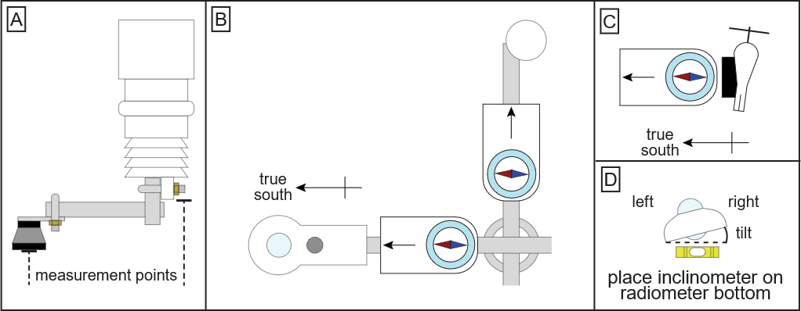

Station name: | SDL |  | Date: | 07-05-2026
STATION HARDWARE
To do? | Done? | Item | Comments
Update program | yes | Loggerbox | ID arrival: M3 – 06  ID departure: M3-06
 |  | Modem IMEI | IMEI arrival: 300534063815680  IMEI departure: 300534063815680
Replace | Yes | Radiometer | Serial arrival: 213250  Serial departure: 110560
Replace | Yes | Wind sensor upper | Type arrival: Black / White  Type departure: Black / White
Replace | Yes | Wind sensor lower | Type arrival: Black / White  Type departure: Black / White
Replace | Yes | Lufft upper
Replace | Yes | Lufft lower
Replace | No | SR50 upper | Reused old sensor
Replace | Yes | SR50 lower
Replace | Yes | Thermistor string | Installed new thermistor string
 |  | Iridium antenna
 |  | Solar panel
 |  | Battery box | Burial under lower lufft: YES / NO  Location if NO:
Replace | no | Mast | No need

NOTES (e.g. sensor damage, must-do at next visit)
We had no extension cable for thermistor, so we installed a new in the old tube. Tube was not extended because cable was too short. Bamboo stick and carbonfiber stake marks the top of the thermistor tube.
New snowboard top 195 cm
Liquidice GNSS installed

